Customer Behaviour & Retention Written Analysis

Objective:
To analyse customer purchasing behaviour across loyalty, churn, geography, payment preferences, and review engagement in order to understand retention dynamics, customer concentration, and behavioural drivers impacting long-term business sustainability.

Approach:
Using SQL-based customer-level aggregations, multiple analytical dimensions were evaluated. Customers were classified by purchase frequency to identify repeat behaviour, and churn status was determined using a recency-based definition relative to the dataset’s latest transaction date. Geographic distribution was analysed by aggregating customers and orders at state and city levels. Payment behaviour was assessed through payment method usage and instalment patterns, while customer satisfaction was explored by linking review scores and review engagement to purchasing frequency. Results were summarised using descriptive metrics such as counts, averages, and percentages to enable behavioural comparison across segments.

Key Findings:
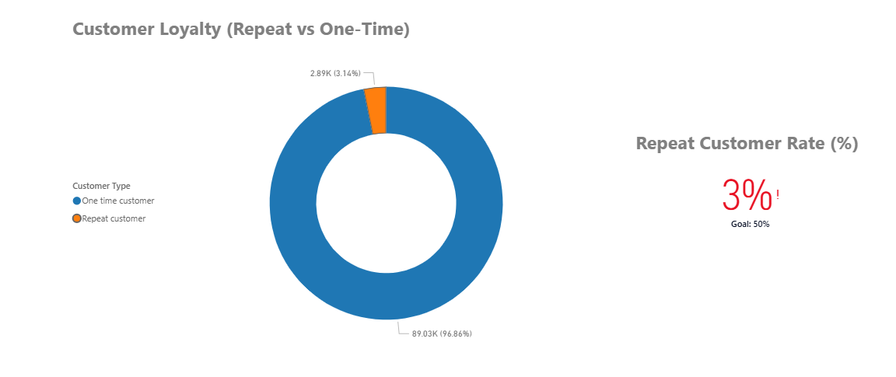
- Customer loyalty is extremely low, with only 3.12% of customers classified as repeat purchasers. The overwhelming majority (over 96%) place a single order, indicating weak retention and limited customer lifetime value under the current operating model.

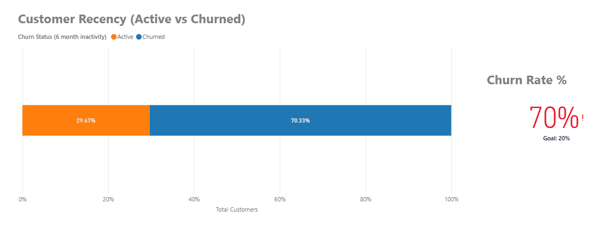
- Churn is structurally high, with 70.33% of customers classified as churned based on recency. This aligns closely with the low repeat customer rate and suggests that most customers disengage shortly after their first purchase rather than lapsing gradually over time.
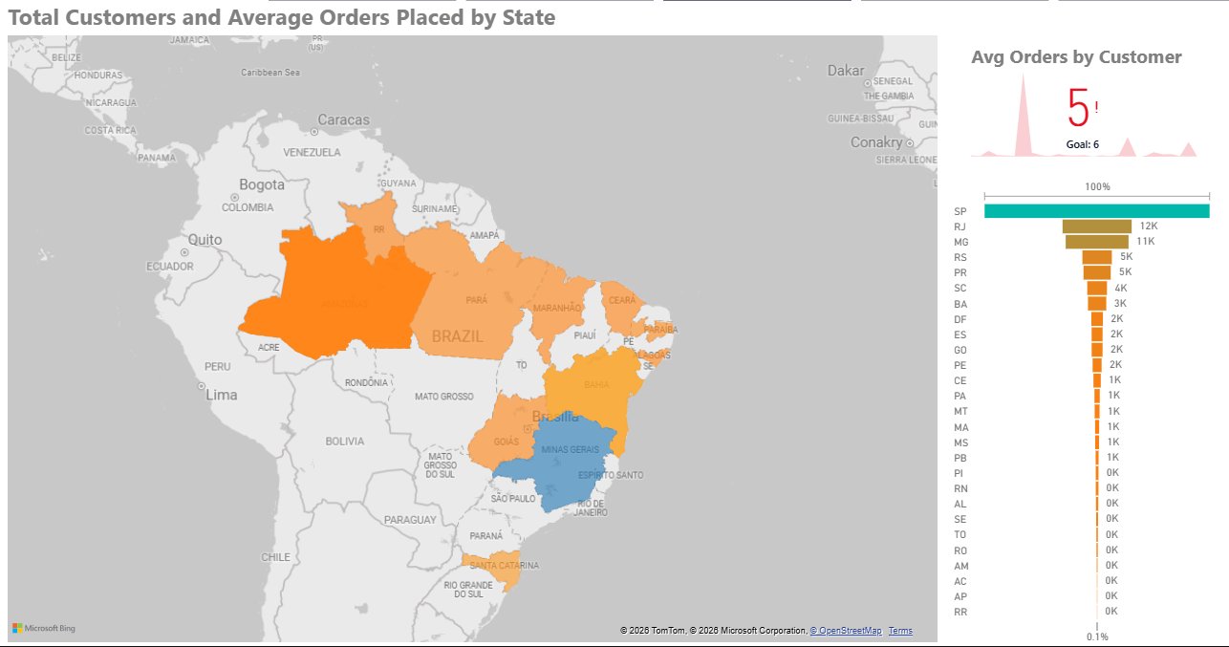
- Customer demand is highly concentrated geographically, particularly in São Paulo (SP) and Rio de Janeiro (RJ). São Paulo alone accounts for a disproportionate share of customers and orders, while secondary cities contribute meaningfully but at much smaller scale. Despite this concentration, average orders per customer remain consistently close to 1.0 across all cities, reinforcing the single-purchase behavioural pattern nationwide rather than being region-specific.
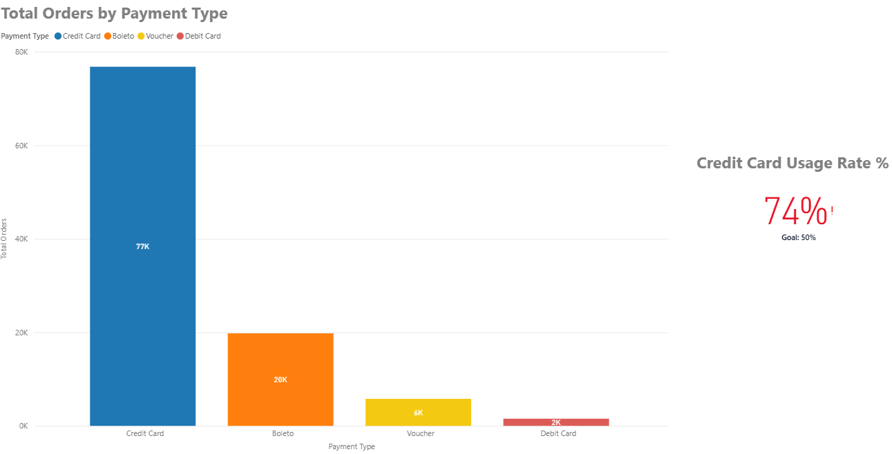
- Credit cards dominate payment behaviour, used by the vast majority of customers and orders. The average of 3.51 instalments for credit card transactions indicates strong reliance on instalment-based purchasing, while alternative methods such as boleto, debit card, and vouchers are primarily used for one-off, single-instalment purchases.
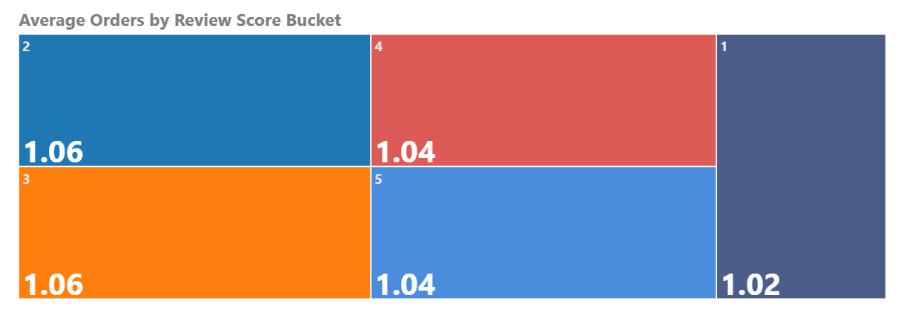
- Customer satisfaction shows limited correlation with repeat purchasing. Across all review score buckets, average orders per customer remain tightly clustered around 1.02–1.06. Even customers providing the highest review scores do not demonstrate meaningfully higher repeat purchase behaviour, suggesting satisfaction alone is not sufficient to drive retention.
- Review engagement (leaving a comment vs. not) similarly does not translate into stronger purchasing frequency, indicating that feedback activity reflects transaction-level sentiment rather than long-term loyalty.

Business Implications:
- Retention represents the largest growth opportunity. With only 3.12% repeat customers and over 70% churn, even modest improvements in retention would have a disproportionate impact on revenue and customer lifetime value. Retention should therefore be treated as a primary strategic priority rather than a secondary optimisation.
- Prioritise post-purchase engagement to drive repeat behaviour. Given that most customers disengage after their first order, structured interventions such as personalised follow-up emails, targeted reactivation campaigns, loyalty incentives, and second-purchase offers are critical to encourage habit formation and repeat purchasing.
- Leverage geographic concentration for focused impact. Customer demand is heavily concentrated in São Paulo and Rio de Janeiro, making these regions ideal for targeted experimentation. Retention initiatives, delivery experience improvements, localised promotions, and customer service enhancements are likely to deliver higher ROI in these high-density markets.
- Optimise instalment-based pricing as a behavioural lever. The dominance of credit card usage and the average of 3.51 instalments suggest that perceived affordability strongly influences purchase behaviour. Promotions, pricing thresholds, and merchandising strategies should be aligned with instalment psychology to improve both acquisition and potential repeat conversion.
- Move beyond satisfaction as a retention strategy. Since high review scores and review engagement do not translate into higher repeat purchase rates, retention efforts should not rely solely on improving transactional satisfaction. Instead, strategies should focus on reinforcing ongoing value, strengthening brand attachment, and providing tangible incentives for return purchases.
Summary:
Long-term growth is constrained primarily by weak retention rather than acquisition. The greatest commercial impact will come from systematically improving repeat purchase behaviour through targeted lifecycle engagement, geographically focused initiatives, and behavioural levers such as instalment-based offers, rather than from incremental improvements to satisfaction alone.

